# CS 255 System Design Document Template

This template lays out all the different sections that you need to complete for Project Two. Each section has guidance to prompt your thinking. You will need to continually reference the interview transcript as you work to make sure that you are addressing your client’s needs. There is no required length for the final document. Instead the goal is to complete each section based on what your client’s needs are. Remove this note when you are finished, and replace all bracketed text with the relevant information.

## UML Diagrams

### UML Use Case Diagram

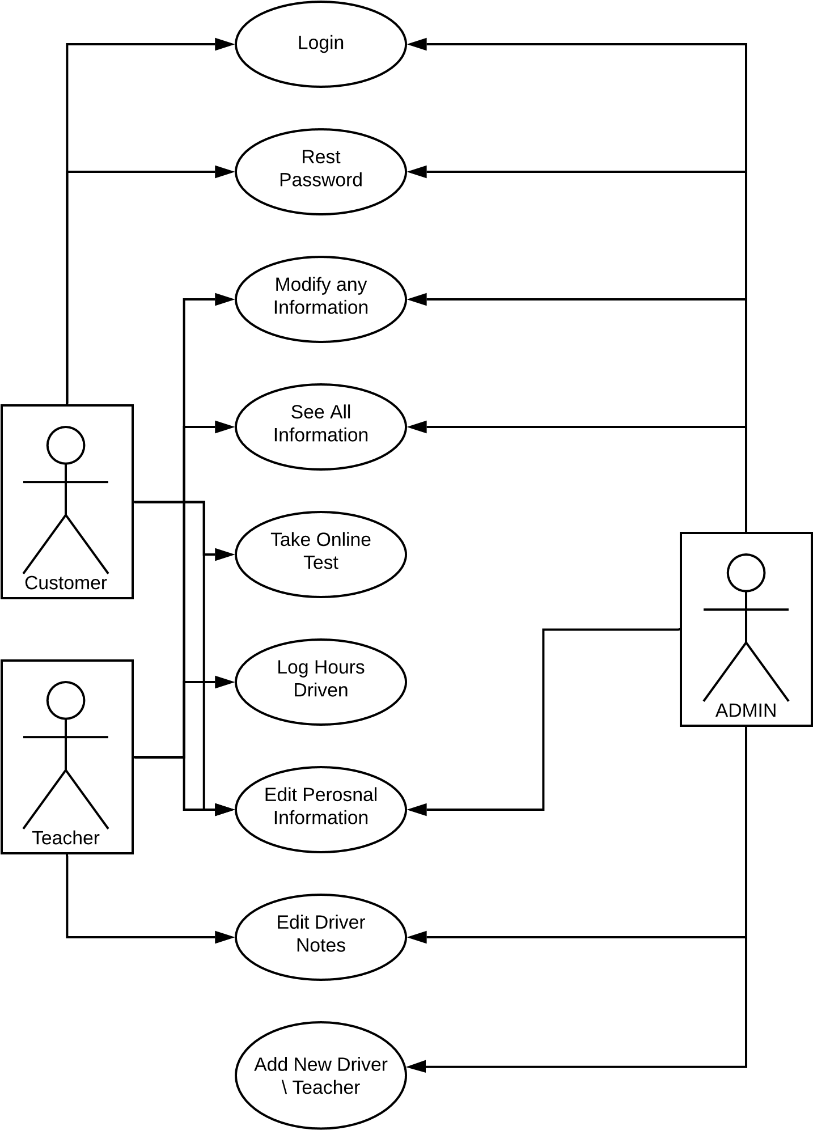

### UML Activity Diagrams

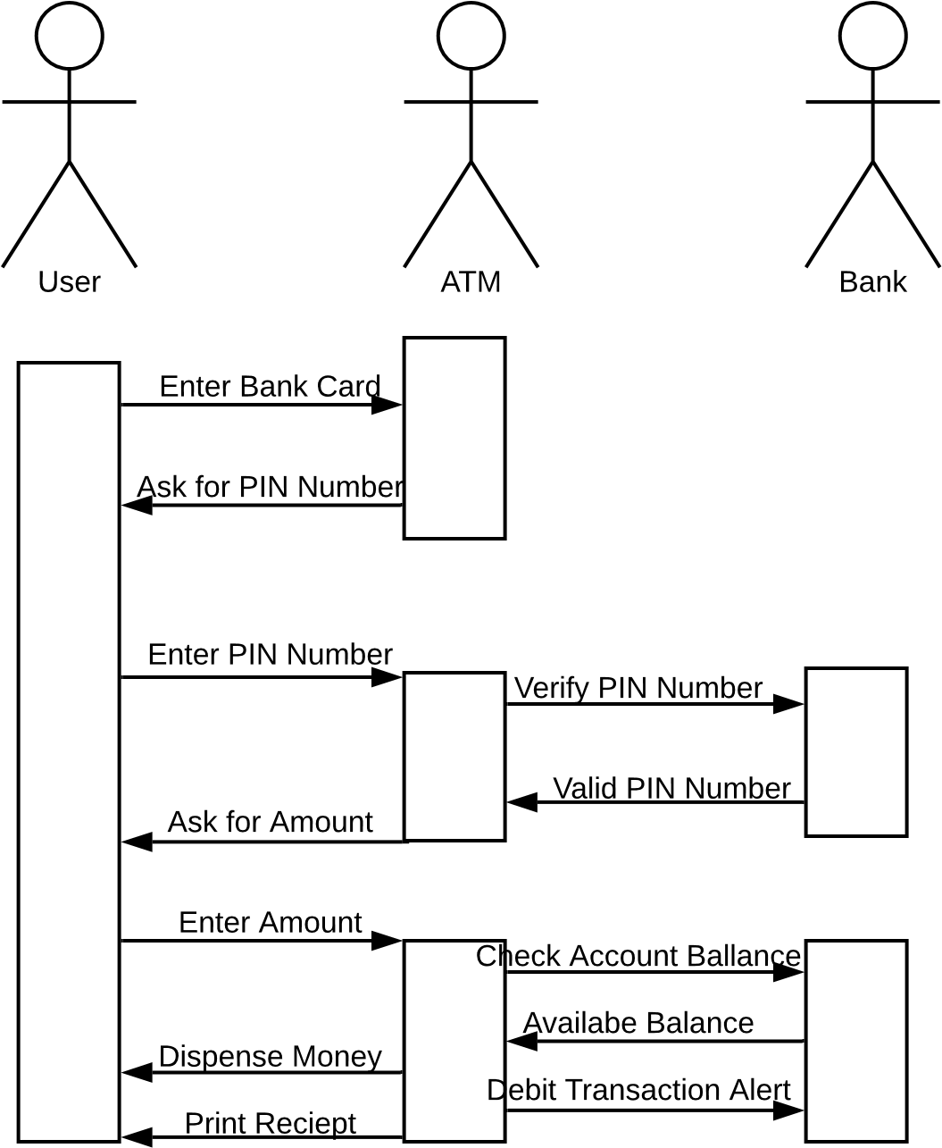

### UML Sequence Diagram

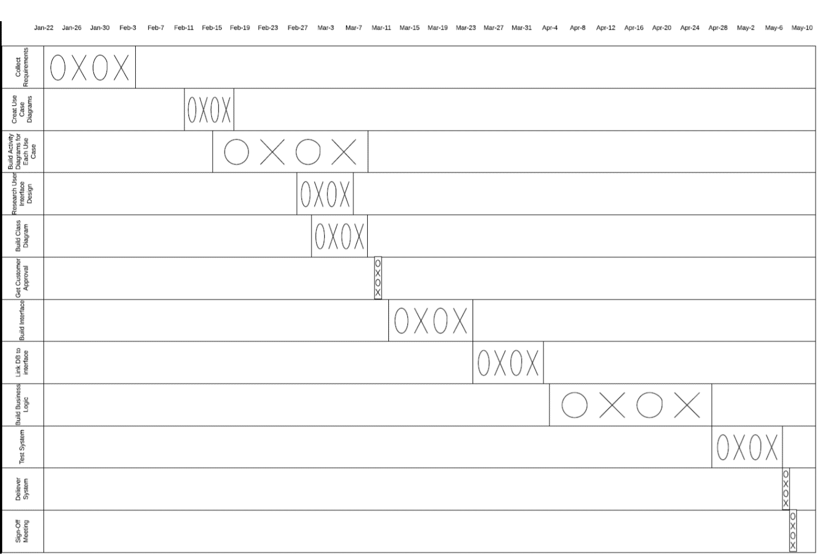

### UML Class Diagram

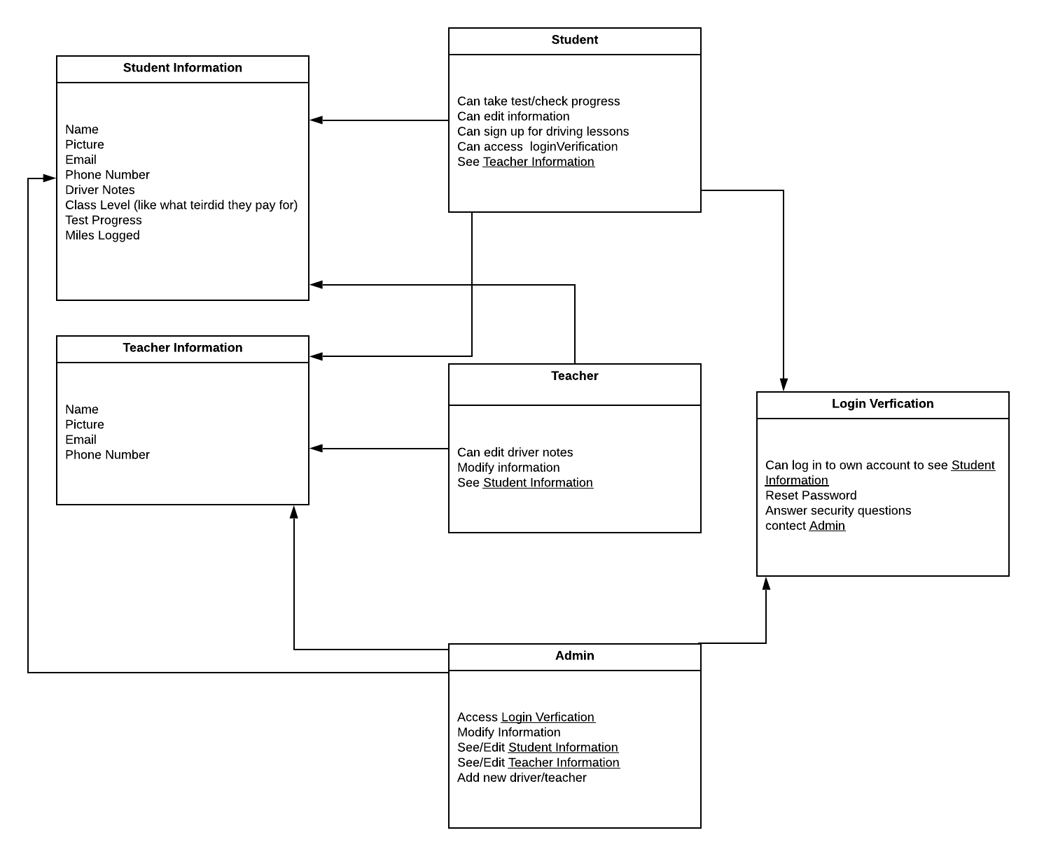

## Technical Requirements

Some of the technical requirements needed for this project include having access to a small server weather it is a physical one or one rented from google itself. A computer to make the software and maintain it. Also, an android and IOS phone to ensure the final versions actually run on the phone. You would need to have a way to port any new laws or regulation that are imposed on people who are currently driving or learning to drive. This way you can stay up to date on any new rules. These are the only technical requirements you would need.